Mertcan Aşgün

63948

Homework 03: Naïve Bayes’ Classifier

Our aim was to classify the given handwritten letters using Naïve Bayes’ Classifier. For this purpose, I started with reading the data from the given data set and dividing them into training and test sets. For this part, I used the same methods and same approach with Homework 2. As an additional note, I want to add something here, given excel file for data set images is named as “hw02_data_set_images”, despite this is Homework 3. I did not change the name, used the original one but just wanted to inform this.

After I have the data in the desired format, I calculated prior class densities:

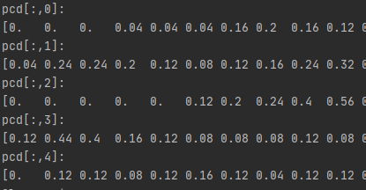

Then calculated the class priors:



And drew parameter estimations as images:

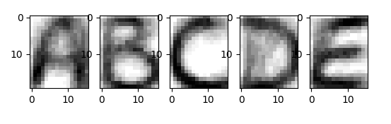

I defined a safelog method to avoid - infinity, which occurs when trying to take logarithm of 0. Then I defined discrimination function. Since, when I start making predictions, I will get the argmax of the value returned from discrimination function, I did not include the last log(P(Ci)) part, which is equal for all classes.

Then I applied my discrimination function on my training set and printed the confusion matrix:

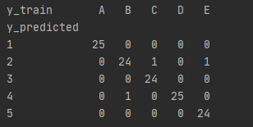

To finalize the homework, this time I applied the discrimination function on the test set and again printed the confusion matrix:

